**Question 5: Disney Characters** (5 points)

Program the select box q5disney.html to display each of the three Disney characters along with their name and quote.

You are to pull the data through an Ajax call from: <https://se251-node.herokuapp.com/final>

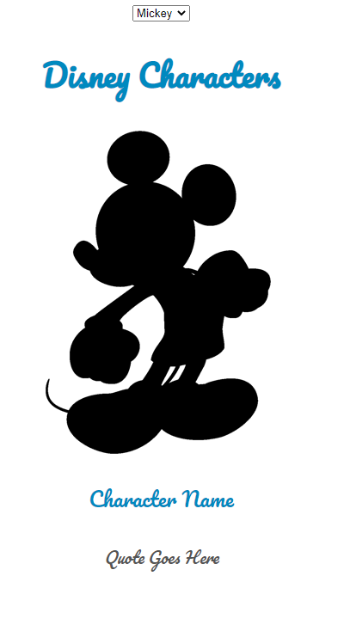

* 1 point - for retrieving and console.log() data.
* 1 point - 1 select box console logs (“working”) on a change event
* 1 point - 1 Image changes to show image of character chosen in the select
* 1 point - 1 Name changes to show chosen character’s name upon select
* 1 point - 1 Characters quote changes to show chosen character’s quote upon select